Walkthrough 15 Nested Views

https://sapui5.hana.ondemand.com/#/topic/df8c9c3d79b54c928855162bafcd88ee

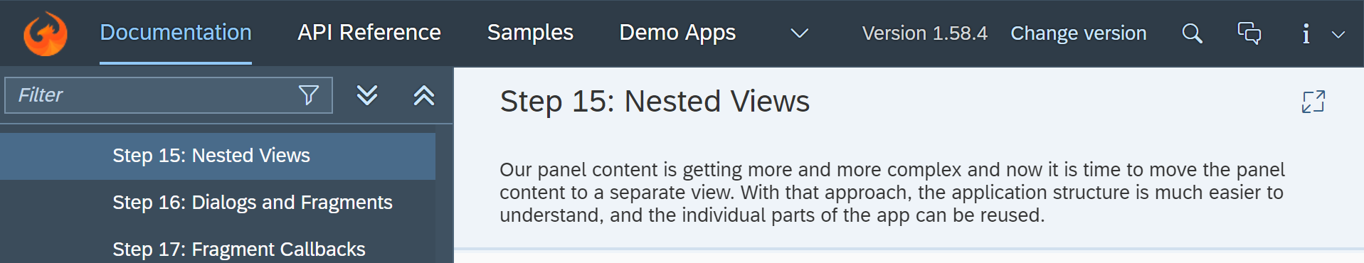

Core Changed Codes Compared to Last Version:

App.view.xml

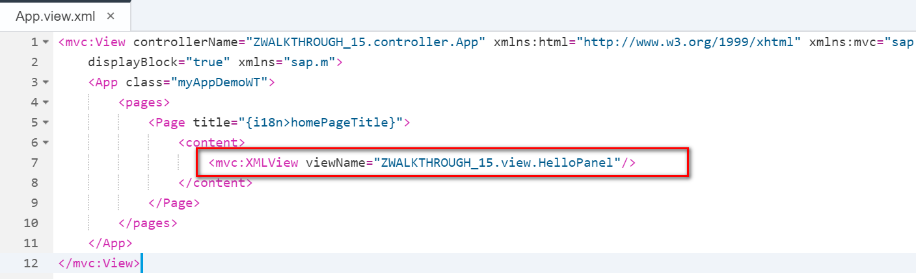

HelloPanel.view.xml

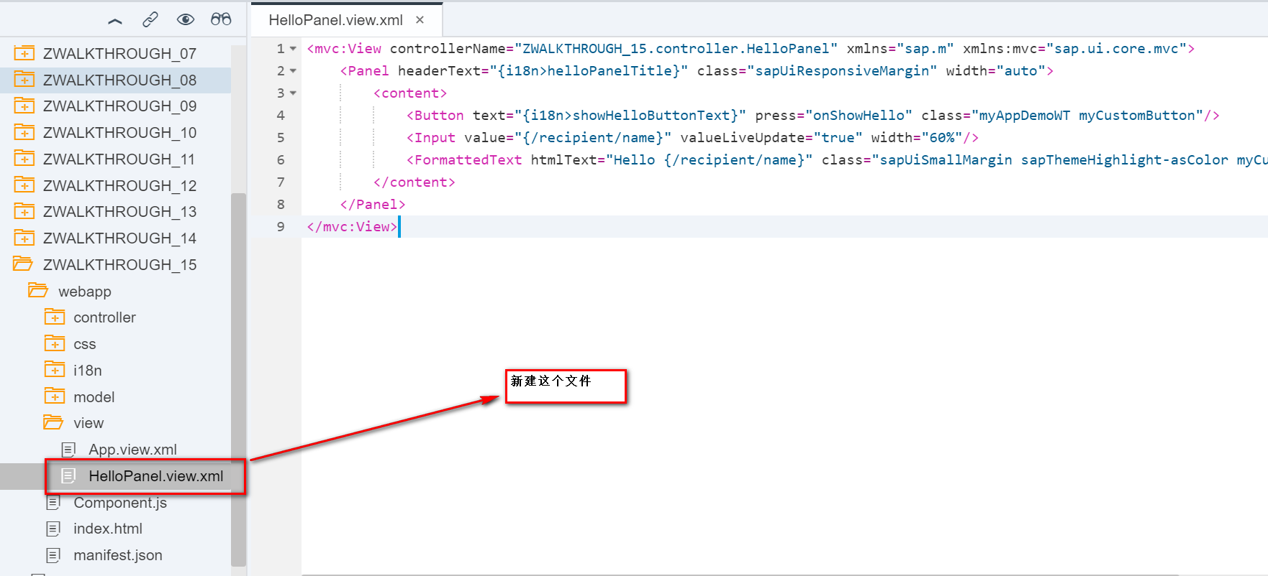

HelloPanel.controller.js

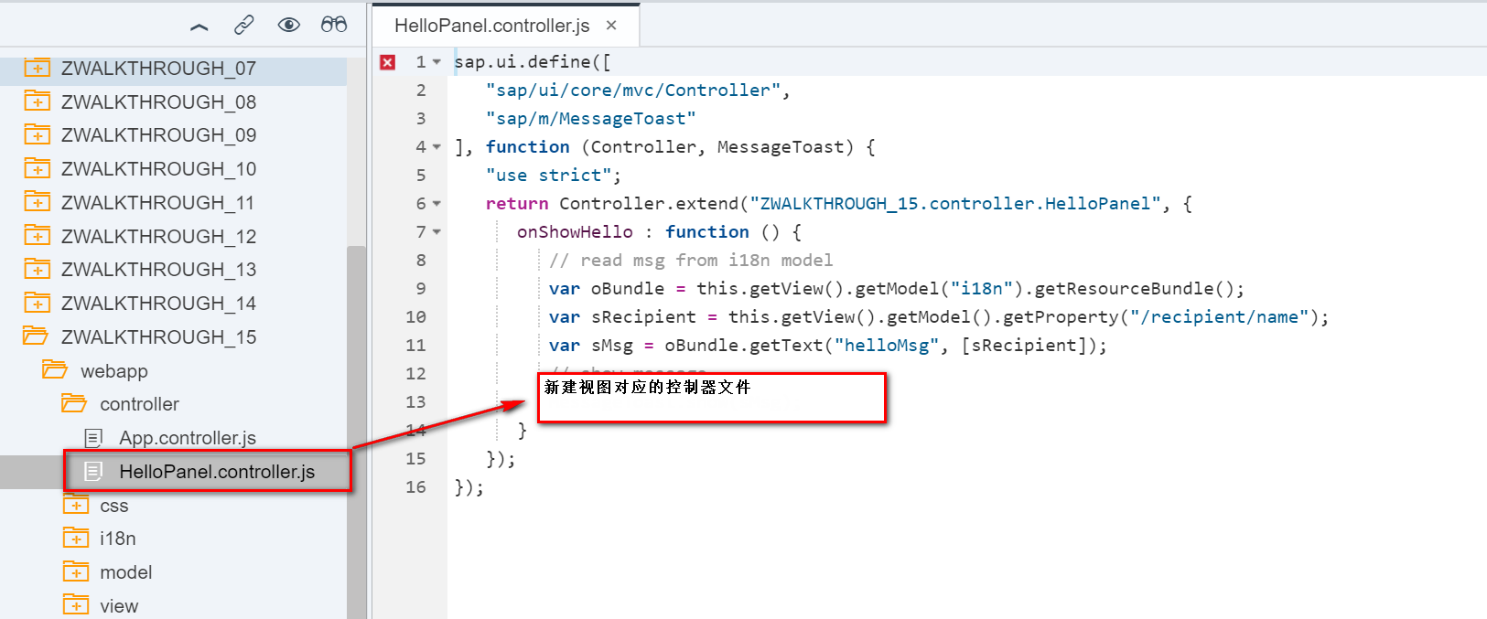

I18n

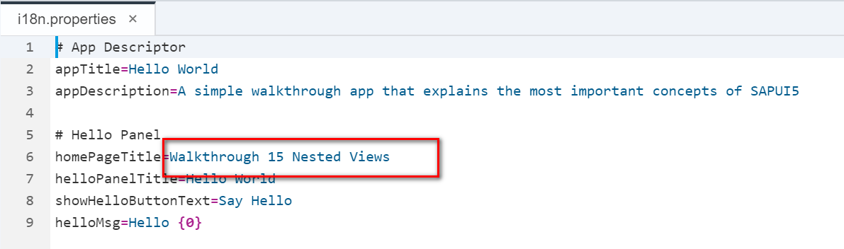

Result:



Git:

https://github.com/xiexiaop/SAPUI5-2-Round/tree/master/Projects/ZWALKTHROUGH_15

2018/11/08 XiaoMi Beijing Zac,Xie